Identification of Unknown “A”
Gillian “Autumn” White
11/30/23
Chem 2081 Section 008
GTA: Dominic Fico

Introduction
In this report, Sample A was identified using NMR, GC-MS, and FTIR. These techniques help provide chemical information of an organic molecule, including organization and composition. NMR, GC-MS, and FTIR are important skills that can be applied to several areas of study, including pharmaceutical fields, comparative studies of molecules, and law enforcement fields when identifying drug compounds.
Body
NMR
NMR spectroscopy allows for the identification of chemical compounds using a technique known as pulsed Fourier Transform NMR also known as FT NMR. The FT NMR instrument is composed of a magnet, magnet coil, probe, NMR tube, spectrometer consol, computer, display unit, and printer that operates at approximately 300-500 MHz. This instrument uses pulses of electromagnetic radiation to excite ¹H or ¹³C nuclei to form a ossicilating, or decaying, sine curve. This curve is also called a free-induction decay (FID) curve as it shows frequencies of the molecules. Compounds can be very complex with sometimes ten to hundreds of frequencies. With the a computer program, these frequencies are placed on a “normal” spectrum that can be analyzed to determine a compound’s chemical structure.
There are four main things that are identifiable using a NMR graph: number of protons, integration, chemical shift, and spin-spin coupling. The number of protons is determined by the numbers of peaks of the graph. The height of each peak is called the integration value. This value interpreted to give each carbon an arrangement of a primary hydrogen, secondary hydrogen, or tertiary hydrogen. Arguably the most important identifier of the NMR graph is chemical shift. Chemical shift is the position of peaks along the horizontal axis. There is a graph of the relative functional groups for each chemical shift position. By combining the chemical shift and integrations of each peak the functional group can be determined at each proton position. Spin-coupling shows the bonding framework of the molecules. By using the pattern of signals at each proton position, the type of coupling can be determined. These show how the functional groups bond together in a molecule.
FTIR
Infrared (IR) Spectroscopy is a technique that identifies the presence or absence of simple functional groups. Molecules are in constant motion. When infared raditon hits a molecule the covalent bonds bend or stretch. This allows the molecule to absorb the infared radiation and increases the molecules kinetic energy. The molecules energy is measured as a wavelength along an x-axis and intensity along the y-axis. A peak along the x-axis represent an IR absorption band. The IR absorption band is where the vibration of a bond occurs. There are multiple forms of bond vibration, including stretching vibration, symmetric stretching vibration, and bending vibration. In stretching vibration the distance between molecules rthymically increase and decrease. While, in symmetric stretching vibration the atoms stretch in and out symmetrically. Then, in bending vibrations the molecules change direction due to the axis. The type of vibration is determined by bond order, atomic mass, electromagnetic differences, and peak intensities.
In order to interpret IR spectra, the classification of the functional group region, fingerprint region, and aromatic region must be determined. The functional group region from 4,000-1,500 cm⁻¹ corresponds to functional groups. The fingerprint region from 1500-900 cm⁻¹ is complex and not commonly used in this identification now. The aromatic region from 900-600 cm⁻¹ is used benzens, aromatic compounds, and alkenes.
Knowing the shape of a peak is also crucial: broad (b), strong (s), medium (m), or weak (w). First, the 1850-1630 cm⁻¹ should be checked. Any peak in this region should categorized and then placed into an appropriate carbonyl group. If it cannot be placed into a carbonyl group, then it can be characterized as either a ketone (1700 cm⁻¹) or a acid chloride (1800 cm⁻¹). Second, the 3500-2850 cm⁻¹ region should be checked. This region can indicate either a hydroxyl group or an amine group. Third, the region from 3310-2850 cm⁻¹ will be checked to determine if what carbon to carbon bonds are present. It can also suggest if an aromatic ring is present. Fourth, the 2280-2100 cm⁻¹ can indicate a triple bond region between two carbons or a carbon and a nitrogen. Fifth, the 1300-1000 cm⁻¹ can help determine the presence of an ether. Last, a list of all notes from the steps should be pieced together to create a chemical structure consistent with the findings.
GC-MS
Electron Impact (EI) mass spectrometry analyzes molecules byusing electron impact to ionize the sample then sort with a magnetic mass analyzer. The mass spectrometer is composed of an ion source, mass analyzer, detector, computer, and mass spectrum. A hybrid instrument built form gas chromotagraoh and mass spectrometer (GC-MS) allows for the analysis of mixture as shows the relative amounts and indentities of components. First, samples from a gas chromotagraph enter a mass spectrometer. These molecules are then ionized and directed to
mass analyzer inside the GC-MS. The mass analyzer sorts the ions by their mass-to-charge ratios noted as m/z. Next, the detector generates an electric current that corresponds m/z ratios to the number of ions. The electric current creates the readable mass spectrum. The data is plotted in a histogram with mass-to-charge ratio on the x-axis and ion intensity on the y-axis.
There are multiple methods used in reading a mass spectrum graph. One method known as the Rule of Thirteen helps generate the chemical formula of a hydrocarbon by dividing the m/z value by 13. The base formula for a hydrocarbon is C_{n}H_{m}. The n value is the whole number that occurs when the m/z value is divided by 13. While, the m value is the remainder added to the n value. The Rule of Thirteen can also be helpful when determining compounds that have other atoms than just carbon and hydrogen. At large peaks there will sometimes be smaller peaks knowns as M+1 and M+2 peaks. These peaks show the natural isotope abundance in a sample. Another method is locating fragmented peaks. Multiple groups have different levels of proneness to fragmentation, incruding aromatic compounds, alkenes, alcohols, and carbonyls. All the methods combined determine the presence of certain function groups and the arrangement of a molecule.
Data
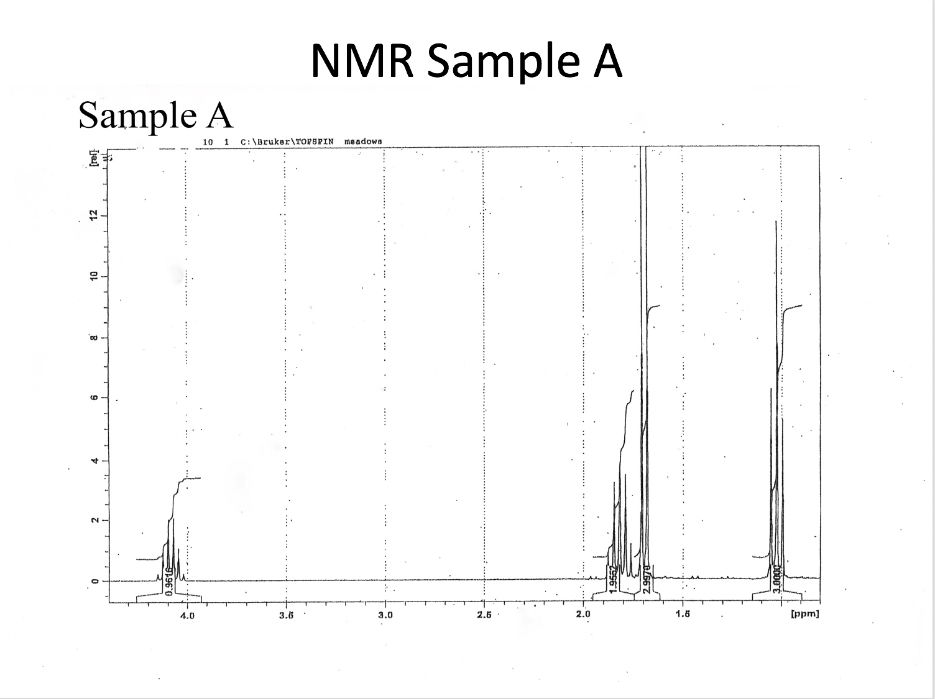
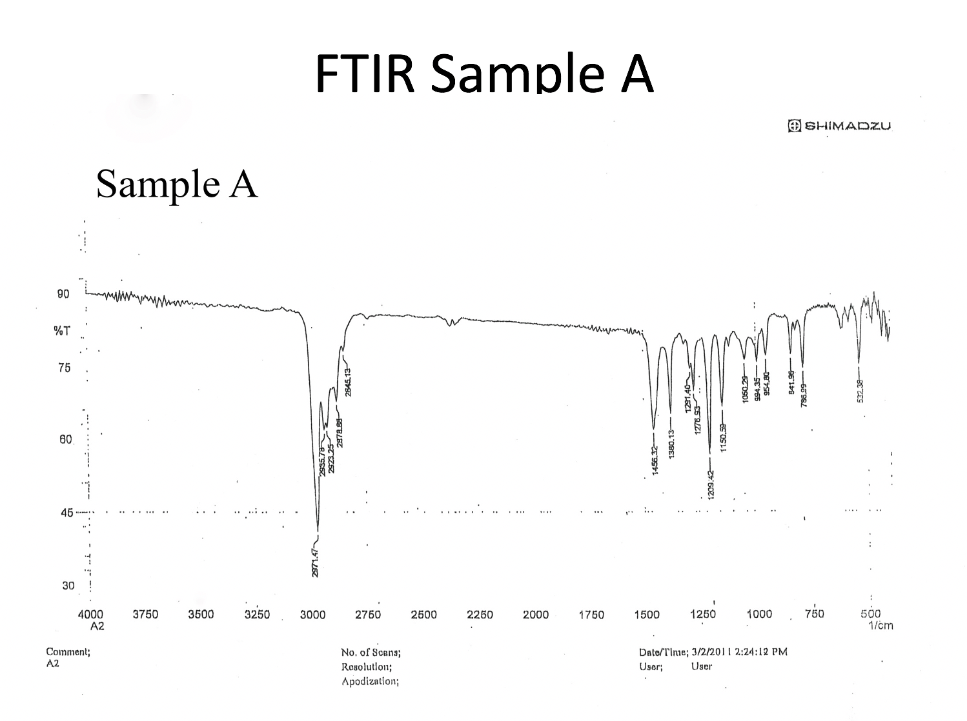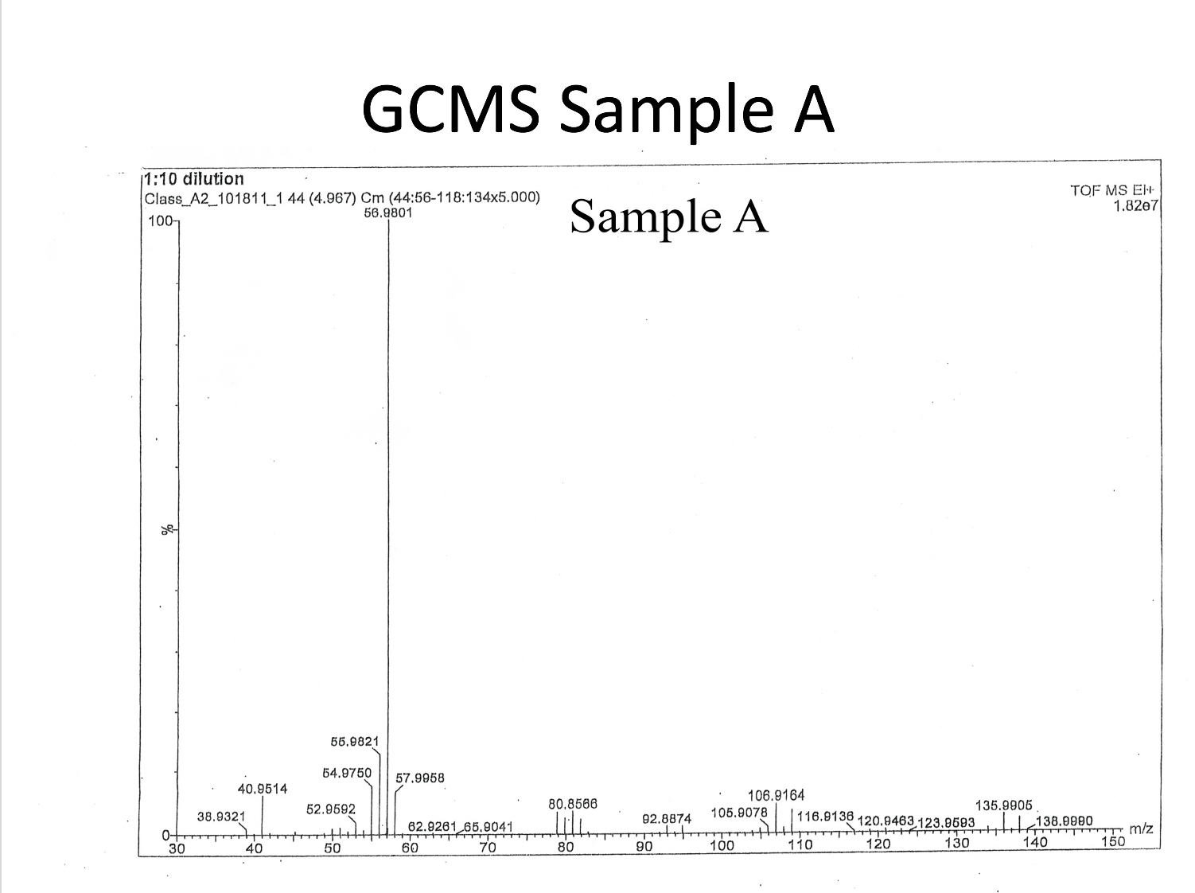

Analysis
What do you see in each spectrum and what does it tell you? Indicate/identify as many functional groups/molecular structures as possible. Justify your identifications. Useful information can be found in the back of the lab manual- Appendix I and II. Use as many other sources as needed.
- NMR
- FTIR
- MS
NMR
Sample A’s NMR has four peaks indicating four protons. From right to left these peaks have the integration values 3.0000, 2.9970, 1.9552, 0.9616. These values are interpreted as 3:3:2:1. Adding these values together there is a total of 9 hydrogens available for 4 protons. From this we can determine our molecule has C₄H₉. The peaks from right to left are labeled A, B, C, D. These can be arranged with A and B on the ends, due to them being methyl groups only attached to a carbon proton. In the middle are C and D, which have 2 and 1 hydrogens respectively. Knowing that location D has only one hydrogen we know that there must be another attachement.
Location D is the left most peak. This peak is at approximately 4.1. Due to the arrangement decided, proton D can be considered deshielded. Which means a halogen group can attach to that proton. This gives a base of CH₃CHXCH₂CH₃.
FTIR
The first thing to checked with peaks is the C-H stretching region at 3310-2850 cm⁻¹. There are peaks in this region in the 2990-2839 cm⁻¹ region indicating no double or triple bonds. These are caused be C-H bond stretching in alkyl groups. The corroborating peaks from 1000-600 cm⁻¹ also indicate that there is C-H bonding. There is one peak at 532.38 cm⁻¹. This strong peak indicates a halide group, more specifically bromine. Therefore, we know there is C-Br bond stretching present. Which can replace X in our base: CH₃CHBrCH₂CH₃.
GC-MS
On the graph there is fragmentated peaks at 136 and 138. They are about the same level which is approximately a 1:1 ratio. This is indicative of ⁷⁹Br and ⁸¹Br isotopes that exist naturally 1:1 ratio. This suggests that there is a halogen group present in the molecule. As there are isotopes at this region the molecular ion peak is going to be an average of 136 m/z and 138 m/z. This gives 137 m/z, meaning the resulting molecule is going to be 137 g/mol.
Using the Rule of Thirteen, 136 m/z would give C₁₀H₂₀Br. However, this does not correspond to previous results. As a result other observations must be made. The base peak is at 57 m/z which accounts for the CH atoms in the molecule. There is also fragmenting at 79 m/z. When subtracting 79 m/z from 136 m/z, there is a remainder of 57 m/z. This shows that there is one bromine molecule attached to the CH atoms.
Conclusion
The molecule has 4 carbon protons and 9 hydrogens according to the NMR results. This is confirmed by the GC-MS as the CH molecular weight is 57 g/mol. A halogen functional group was suggested by NMR and confirmed with FTIR and GC-MS. According to the peak at 532.38 cm⁻¹ on FTIR, bromine is the halogen. Bromine is confirmed with the isotope ratio from GC-MS. This gives a molecule with the molecular formula C₄H₉Br. This can be written as H₃C-CHBr-CH₂-CH₃ to indicate the molecules structure. The name of the molecule is 2-bromobutane.
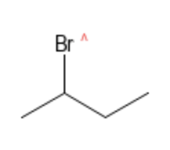
References
Keller L, Joseph K, and Miguel S. 2023 Fall. CHEM 2081 Organic Chemistry 2 Lab Manual [lab manual]. Auburn (Al): Auburn University.

